WW Solutions
Mobile Version

Project Team – 1

Armanpreet Kaur 4535488
Jasdeep Kaur 4535999
Keshav Sharma 4532854
Saloni Bedi 4531676
Introduction
Project Overview
In this project, we are transforming a website named www.worldwirelesssolutions.com into the mobile version. We must make sure that the current website must work effectively on the mobile devices and its dimensions must fit as per the mobile’s aspect ratio. The mobile version includes navigations, search and forms which must be functionable, thus enhancing the user experience and user reach.
Significance
The main points to keep in consideration are seamless experience across various screen sizes which will boost the user experience and increase the number of visitors on the application. However, this will result in better business outcomes. Other than that, database must be stored securely and should archive the user information for providing an ease of access.
Goals and Objectives
- Mobile version of the website must adapt to different screen sizes such as smartphones and tablets.
- The main task in the project is securely storing the user information, processing transactions, managing dynamic data (content on a web page that changes based on the factors like user data, user location, and user signals.)
- Data security should be main target to protect sensitive information along with data protection regulations.
Scope
During the development process of the application, we might face the risks in the following sectors like technical, data security and time constraints. However, to overcome these risks we can follow some measures such as testing and quality assurance, security measures and project management. By following these procedures, we will encounter some benefits namely enhanced user experience, improved data management and security operational efficiencies.
Possible risks
- Technical risk
    - Data integration between mobile application and the website must be challenging. For example, individual changes their personal information, it should be reflected on the mobile application and the website simultaneously.
    - Bugs and errors during testing and development.

- Data security
    - Data can be accessed by unauthorized people or the parties this security incident is known as data breach.
    - Executing encryption (producing cipher text) and data storage solution.
    - Any weakness in the application could be exploited by the hackers.
- Time constraints
    - Risk of not meeting project timelines or deadlines.
    - Delays due to technical issues or complexity in development.

Risk management plan
- Testing and quality assurance
To prevent the risks like integration bugs and potential we must undergo regular quality assurance checks throughout the development process.
- Security Measures
Security audits, evaluation of a company’s information system, network and physical structure can be best practice to prevent security risk.
- Project Management
Regularly review the project timelines and milestones to ensure timely development of the application.

Benefits
- Enhanced User Experience
As it is a mobile application so users can easily visit website on their mobile devices rather than carrying laptops and tablets along with them, this will enhance the user experience.
- Improved data management and security
Legal data management through data protection regulations.
User information and transactions must be managed through smooth process.
- Operational Efficiency
For Future growth and advancement database must be well designed.
Project Background and related work
Overview
For this project, we overview 10 articles of related work to understand how to develop mobile application.

- Responsive web design
    - Article survey: During the development of mobile application its important to automatically set content and elements according to screen size on which it is viewed/
    - Key Findings: It may enhance user-experience and involvement with applications.
- Adaptive web design
    - Article survey: As we have website for that fits for large screen whereas we are creating mobile version which fits best for the small size. Here, we must make different layouts for the different screen size.
    - Key Findings: From here we understood, the importance of creating different versions of web pages that fits user device.
- Mobile-first Design
    - Article survey: In this approach, we should design elements of applications according to mobile user and the moving to larger screen size.
    - Key Findings: upgrade user-interaction and UX design.
- Progressive web apps
    - Article survey: It’s an application that is designed by using web-platform technologies but provides user experience like platform specific application.
    - Key Findings: it makes website more reliable and interactive.
- Data Management
    - Article survey: For database management we use some of the methods such as tables, data-verse and MySQL.
    - Key Findings: Powerful database management results in data performance, scalability and integrity.
- Security in mobile development
    - Article survey: To protect data from cyberattacks and data theft.
    - Key findings: vulnerability testing, secure API’s and encryption are some measures for protecting mobile development.
- User Experience (UX)
    - Article survey Design for mobile Navigation, fast load times, touch-friendly interfaces. Performance optimization and personalization are some components of mobile user experience.
    - Key Findings: However, these features might increase reach of the application.
- Performance optimization
    - Article survey Choosing correct data structure, monitor performance, caching and code optimization are techniques used for performance optimization.
    - Key Findings: Reduce load time and improves user experience.

- Data synchronization
    - Article survey In this project, we have existing website for which we are developing mobile application so maintaining data consistency between both over specific time is important part of the project.
    - Key findings: Better data synchronization ensures data consistency.
- Accessibility in mobile web design
    - Article survey Making application more convenient for people with disabilities.
    - Key Findings: screen readers, pinch/zoom support and external keyboards with/without keypads are some features involved which will help out Differently abled individuals.
Company Information
- Project Manager
    - As a Project Manager, Individual should have knowledge in stakeholder communication and risk assessment as well as experience in resource management and project planning.
    - Roles and responsibilities in this project is to manage the budget, overview the entire structure of the project along with the communication among the team members.
- Database Administrator
    - As a Database developer, one should have expertise in SQL/NoSQL databases, data security, data structure and enhancing performance levels.
    - Duties in this project lies around building and overseeing the database, make sure of the effectiveness in data processing and safeguarding the User data by using the safety protocols.
- UX/UI designer
    - The skills and areas of expertise should be designing the user interface and prototyping along with usability testing.
    - As a Designer, roles and responsibilities are designing the entire user interface, developing the wireframes and prototypes for the mobile application specifically in order to provide seamless experience and an ease of access to the mobile users.
- Quality Assurance Tester
    - Being a tester, one should be able to track the bugs, look for the compatibility between the devices of different screen sizes and aspect ratios and should have knowledge of methodologies testing.

Project Plan – Timeline and Milestones
- Project Initiation
    - Milestone: - Project Building Meeting
    - Duration: - 1 Week
    - Description: - Explaining project goals and objectives, distributing the roles among the team.
- Collecting the required Information
    - Milestone: - Review and approvals from the stakeholders
    - Duration: - 2 Weeks
    - Description: - Compiling and recording the required specifications for the database and the mobile application.
- Designing Stage
    - Milestone: - Final Touches to the UX/UI design
    - Duration: - 3 Weeks
    - Description: - Analyzing and completing the designing portion of the Mobile application.
- Development Stage
    - Milestone: - Front-end Development ended
    - Duration: - 4 Weeks
    - Description: - Added the navigation buttons, forms for input of the user data and describing the information as that on the website.
    - Milestone: - Back-end Development ended
    - Duration: - 5 Weeks
    - Description: - Completing the database development, storing the User Data in the database structure ensuring that data protection and management is guaranteed.
- Examination Stage
    - Milestone: - Complete Integration
    - Duration: - 2 Weeks
    - Description: - Compiling the front-end, back-end and database to ensure the integration.
    - Milestone: - Final Testing and Quality assurance
    - Duration: - 3 Weeks
    - Description: - Dealing with the bugs and issues. Checking performance and functionality. Ensuring data security.
- Deployment Stage
      - Milestone: - Deploying the project to the production team
      - Duration: - 1 Week
      - Description: - Launching the Mobile Application along with the latest Database making sure of keeping out any problems or glitches.
- Post-Deployment Stage
    - Milestone: - User training and support
    - Duration: - 2 Weeks
    - Description: - Providing personnel support guide and training the users. Reviewing the Concerns and suggestions after the launch.

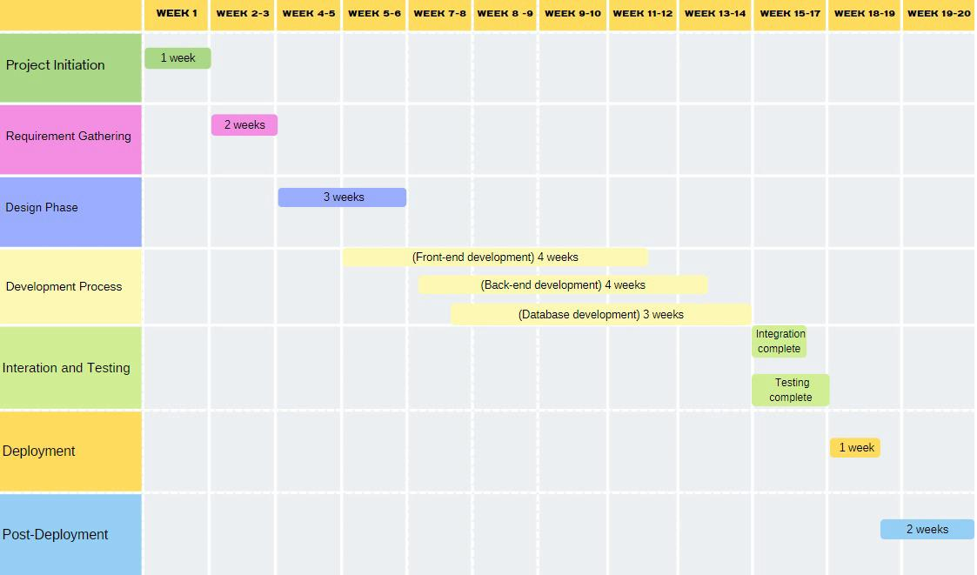

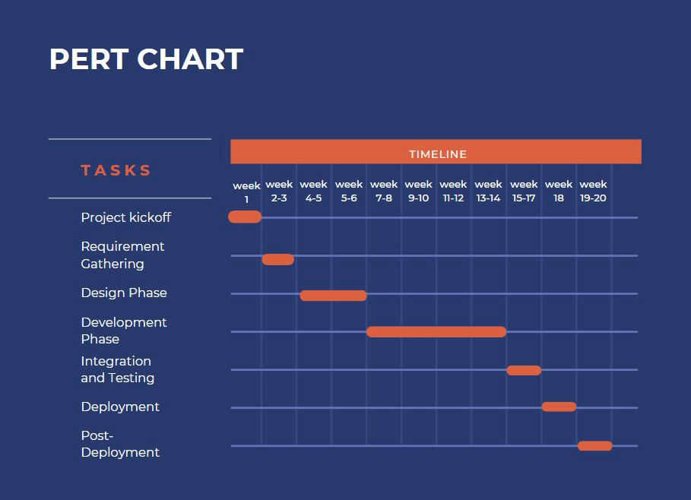
Software Requirements and Data Flow Diagrams
- Responsive Design
- Description: Adjustable layouts for different desktop and mobiles screen sizes.
- Benefits: providing uniform information across various platforms, thus increasing the usability of users.
- Data Integration
- Description: Interact the Application with the data sources like Dataverse, SQL Server and Share point.
- Benefits: Ease of storing and managing the dynamic user data.
- Workflows and forms
- Description: The user should be able to upload the personal information using the integrated forms within the application.
- Benefits: This will enhance the task management and business operations.
- CRUD operations
- Description: The application should feature the Creation, Reading, Updating and Deletion of the user records.
- Benefits: This will help in managing the required data by providing the updated user data in the database.
- Performance and Usability
- Description: The application should provide easy to use interface along with the navigation features.
- Benefits: Provides seamless experience at its potential alongside saving the time of the user.
- Availability and Expandability
- Description: No performance drops while handling the excess of user data and also providing the integration among the other devices.
- Benefits: Providing the constant access to the data. As a result, growing the application as per future needs.
Software tools
- Microsoft Power Apps
- Description: A low-code framework helps in developing an application’s front-end using the canvas drag and drop features.
- Benefits: Ease to access to Microsoft Teams and saves time by fast development.
- Microsoft Dataverse
- Description: Platform for creating and storing the data and managing the entities.
- Benefits: Provides the secured data storage within the Microsoft Power Apps which helps in saving the time by working in the same framework.
- Microsoft Sharepoint
- Description: Platform for collaborating with the peers while sharing and storing the documents.
- Benefits: Helps in managing the documents within the Microsoft Power Apps.

- SQL Program
- Description: Providing the Relational databases which is used to store structured data.
- Benefits: Securely handles and retrieves the data for larger datasets.
References
- Microsoft. Microsoft Power Apps documentation. https://learn.microsoft.com/en-us/power-apps/
- Microsoft. Microsoft Dataverse documentation. https://learn.microsoft.com/en-us/power-apps/maker/data-platform/data-platform-intro
- Microsoft. SQL sever tutorials. https://learn.microsoft.com/en-us/sql/sql-server/?view=sql-server-ver16
- Marcotte E. Responsive web design. A List Apart.
https://alistapart.com/article/responsive-web-design/
- Wroblewski, L. Forms of Mobile Devices. Smashing Magazine https://www.smashingmagazine.com/2010/03/forms-on-mobile-devices-modern-solutions/
- Wikipedia. Progressive web apps. https://en.wikipedia.org/wiki/Progressive_web_app
- Desai B.C. An Introduction to database systems. https://spectrum.library.concordia.ca/988586/1/An-Introduction-to-Database-Systems-Bipin-C.DESAI.pdf
- Wang H. UX Deliverables. https://www.nngroup.com/articles/ux-deliverables-glossary/
- Mitrofanskiy K. Mobile Synchronization. https://intellisoft.io/implementing-offline-data-synchronization-in-logistics-applications/
- Rank S. 10 web design principles to increase accessibility. https://www.audioeye.com/post/10-web-design-principles-to-increase-accessibility/

